**SENG2050 Web Engineering - Assignment 3**

**C3180044_C3281849_C3237808_FinalProject**

**Draft Documentation**

**CONTENTS**

**Use Case Diagram2**

**Use Case Descriptions3**

**Content Model10**

**Navigation Model11**

**Presentation Model12**

**Development Plan13**

Task Allocation13

Integration Plan13

Timeline13

**Use Case Diagram**

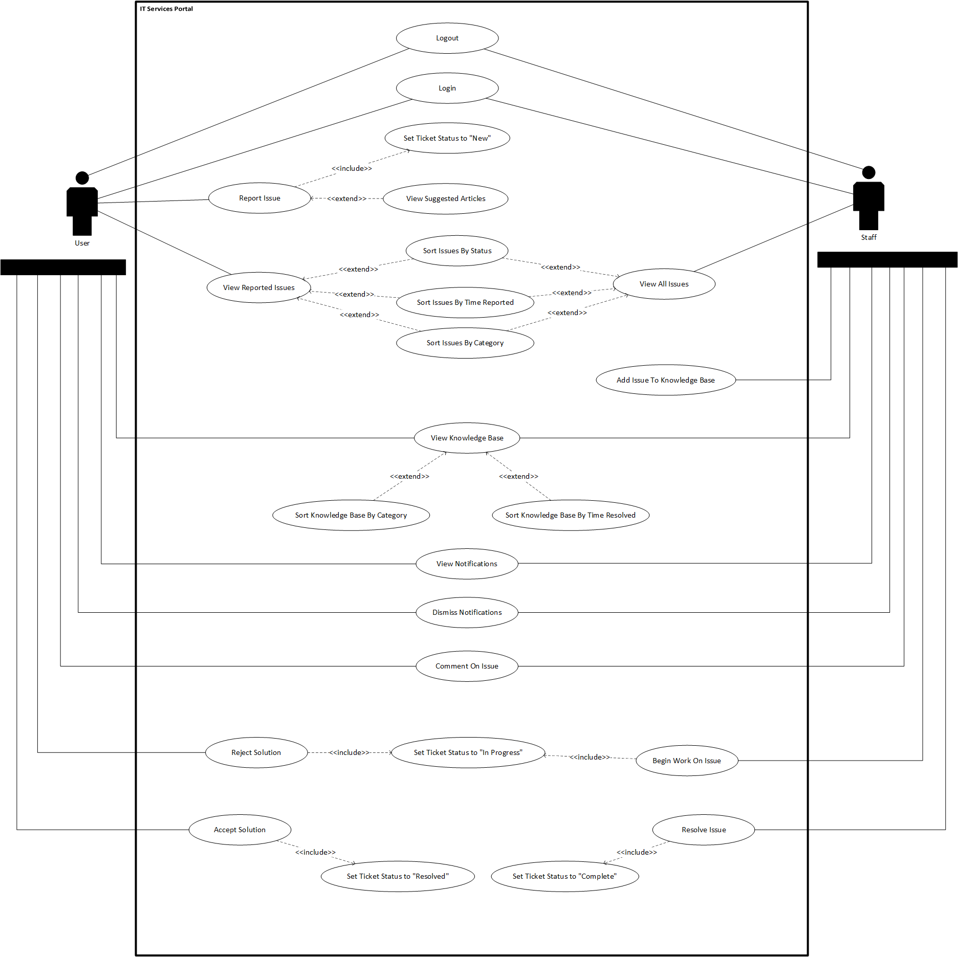

**USE CASE DESCRIPTIONS**

|  |  |
| --- | --- |
| Use Case Name: | Login |
| Description: | User/Staff login into the system to access features relevant to the IT Support System. Once the User or Staff has logged in with their email and password, they will be presented with their account role’s service portal. |
| Actor: | User, Staff |
| Preconditions: | 1. Must have valid account |
| Postconditions: | 1. System displays service portal |
| Main Flow: | 1. The user enters their email and password 2. The user submits email and password 3. The system validates the email and password 4. The system displays the service portal |
| Alternative Flow: | 3a Incorrect email and password   1. Prompts user for email and password 2. Use Case resumes at main flow step 1 |

|  |  |
| --- | --- |
| Use Case Name: | Logout |
| Description: | User/Staff logout of the system once they are done. Once logged out, the user will be presented with the login page if they wish to login again. |
| Actor: | User, Staff |
| Preconditions: | 1. User must have valid account 2. User must be logged into account |
| Postconditions: | 1. Display Login Page |
| Main Flow: | 1. User clicks on Logout button 2. The system displays Login page |

|  |  |
| --- | --- |
| Use Case Name: | Report Issue |
| Description: | Users report an issue they are having. Once clicked on, the user is presented with a form that will request all information regarding the issue they are experiencing. The form is then sent to the IT Staff for Inspection. |
| Actor: | User |
| Include Use Cases: | 1. Set ticket status to “New” |
| Preconditions: | 1. The User is logged in |
| Postconditions: | 1. Update Support Tickets 2. Notify IT Staff 3. Return to Portal |
| Main Flow: | 1. User clicks report issue 2. User fills in form 3. (Extension Point: View suggested articles) 4. User submits form 5. Form is validated 6. Issue is sent to IT Staff 7. Issue Status is set to “New” 8. The system displays the portal |
| Alternative Flows: | 4a Invalid or Empty form   1. Prompt user to fill form 2. Repeat from main flow 2 |

**USE CASE DESCRIPTIONS**

|  |  |
| --- | --- |
| Use Case Name: | Set Ticket Status to “New” |
| Description: | Sets the status of a newly created issue to “New” and awaits for IT Staff to Begin work on issue. |
| Actor: | User |
| Preconditions: | 1. The user has submitted an Issue |
| Postconditions: | 1. IT Staff is notified |
| Main Flow: | 1. Status of Issue changed to “New” |

|  |  |
| --- | --- |
| Use Case Name: | View Suggested Articles |
| Description: | User sees Knowledge Base articles that are related to the issue they are submitting by searching for keywords. |
| Actor: | User |
| Extend Use Cases: | 1. Report Issue |
| Preconditions: | 1. The user types in the title |
| Postconditions: | 1. Suggest Articles from Knowledge Base |
| Main Flow: | 1. The system takes in the title keywords 2. The system retrieves Knowledge Base articles from DB that contain keywords 3. The system displays the Articles |

|  |  |
| --- | --- |
| Use Case Name: | View Reported Issues |
| Description: | User views all issues that they have created. Once the user clicks on the view reported issue button, they will be redirected to the Issue page. The user is then allowed to sort by Time reported, Category or Status. |
| Actor: | User |
| Preconditions: | 1. The user has logged in 2. The user has submitted issues |
| Postconditions: | 1. Show Issue |
| Main Flow: | 1. The user clicks on the View Reported Issue Button 2. The system retrieves user Issues from Database 3. The system displays the user Issues 4. (Extension Point: Sort Issues by Status) 5. (Extension Point: Sort Issues by Time Reported) 6. (Extension Point: Sort Issues by Category) |
| Alternative Flow: | 2a No Reported Issue   1. Alerts user of no reported Issue 2. Use case resumes at main flow step 1. |

**USE CASE DESCRIPTIONS**

|  |  |
| --- | --- |
| Use Case Name: | View All Issues |
| Description: | Allows the IT Staff to view all the issues in the System. Once they click on the view issues button, they are redirected to the Issue page where the issues are displayed. They are also allowed to sort the issues in the manner that they like. This includes sorting by Time Reported, Category or by Status. |
| Actor: | IT Staff |
| Preconditions: | 1. The staff has logged in 2. 2. Issues have been reported |
| Postconditions: | 1. Show reported Issues |
| Main Flow: | 1. The IT Staff clicks on View all Issues button 2. The system retrieves the user Issues from Database 3. The system displays the User Issues 4. (Extension Point: Sort Issues by Status) 5. (Extension Point: Sort Issues by Time Reported) 6. (Extension Point: Sort Issues by Category |
| Alternative Flows: | 2a No Issues   1. Alert Staff of No Issues 2. Use case resumes at main flow step 1. |

|  |  |
| --- | --- |
| Use Case Name: | Sort Issues by Status |
| Description: | Allows both the User and Staff to sort the issues they want to view by Status. |
| Actor: | User, IT Staff |
| Extend Use Cases: | 1. View Reported Issues 2. View All Issues |
| Preconditions: | 1. Issues have been reported |
| Postconditions: | 1. Sorted Issues by Status |
| Main Flow: | 1. The system receives the request to sort by Status 2. The system request issues from Database 3. The system sorts issues by Status 4. The system displays sorted Issues by Status |

|  |  |
| --- | --- |
| Use Case Name: | Sort Issues by Time Reported |
| Description: | Allows both the User and Staff to sort the issues they want to view by the time reported. |
| Actor: | User, IT Staff |
| Extend Use Cases: | 1. View Reported Issues 2. 2. View All Issues |
| Preconditions: | 1. Issues have been reported |
| Postconditions: | 1. Sorted Issues by Time Reported |
| Main Flow: | 1. The system receives request to sort by time reported 2. The system requests issues from database 3. The system sorts issues by time reported 4. The system displays sorted issues by time reported |

**USE CASE DESCRIPTIONS**

|  |  |
| --- | --- |
| Use Case Name: | Sort Issues by Category |
| Description: | Allows both the User and Staff to sort the issues they want to view by Category. |
| Actor: | User, IT Staff |
| Extend Use Cases: | 1. View Reported Issues 2. View All Issues |
| Preconditions: | 1. Issues have been reported |
| Postconditions: | 1. Sorted Issues by Category |
| Main Flow: | 1. The system receives the request to sort by Category 2. The system request issues from Database 3. The system sorts issues by Category 4. The system displays sorted Issues by Category |

|  |  |
| --- | --- |
| Use Case Name: | Add Issue to Knowledge Base |
| Description: | Allows the IT Staff to add an issue that is set to “Resolved” or “Completed” to the Knowledge Base. By opening the issue and clicking the Add to KB Button, the issue will now be available in the Knowledge Base for others to view. |
| Actor: | IT Staff |
| Preconditions: | 1. Issue is “Completed” or “Resolved” |
| Postconditions: | 1. Return to Issues |
| Main Flow: | 1. IT Staff clicks button to add Issue to KB 2. System generates copy of Issue 3. System adds copy to Knowledge Base 4. System displays Issue Page |

|  |  |
| --- | --- |
| Use Case Name: | View Knowledge Base |
| Description: | Users view the collection of Articles that are available in the Knowledge Base which may assist in any problems the user is having. The knowledge base is also able to be sorted to assist in which category the user is having trouble in. |
| Actor: | User, IT Staff |
| Preconditions: | 1. The user is logged in 2. The Knowledge Base is populated with Articles |
| Postconditions: | 1. Show Knowledge Base articles |
| Main Flow: | 1. The user clicks on the View Knowledge Base button 2. The system requests All KB articles from database 3. (Extension Point: Sort Knowledge Base by Category) 4. (Extension Point: Sort Knowledge Base by Time Resolved) 5. The system displays all Knowledge Base Articles |
| Alternative Flows: | 2a No Knowledge Base Articles   1. Alert user of empty KB 2. Use case resumes at main flow step 1 |

**USE CASE DESCRIPTIONS**

|  |  |
| --- | --- |
| Use Case Name: | Sort Knowledge Base by Category |
| Description: | Allows both the User and Staff to sort the Knowledge Base Issues by their respective category. |
| Actor: | User, IT Staff |
| Extend Use Cases: | 1. View Knowledge Base |
| Preconditions: | 1. The Knowledge Base is not empty |
| Postconditions: | 1. Sorted Knowledge base by Category |
| Main Flow: | 1. The system receives request to sort by Category 2. The system requests KB issues from database 3. The system sorts issues by category 4. The system displays sorted issues by category |

|  |  |
| --- | --- |
| Use Case Name: | Sort Knowledge Base by Time Resolved |
| Description: | Allows both the User and Staff to sort the Knowledge Base Issues by the time resolved. |
| Actor: | User, IT Staff |
| Extend Use Cases: | 1. View Knowledge Base |
| Preconditions: | 1. The Knowledge Base is not empty |
| Postconditions: | 1. Sorted Knowledge base by Time Resolved |
| Main Flow: | 1. The system receives request to sort by Time Resolved 2. The system requests KB issues from database 3. The system sorts issues by time resolved 4. The system displays sorted issues by time resolved |

|  |  |
| --- | --- |
| Use Case Name: | View Notifications |
| Description: | Allows both the User and Staff to view notifications that have been assigned to them. By clicking on the notification, the user is taken to the Ticket where they can then view or edit. |
| Actor: | User, IT Staff |
| Preconditions: | 1. User has been assigned a notification |
| Postconditions: | 1. The ticket is displayed |
| Main Flow: | 1. The User clicks on the notification tab 2. The system retrieves notifications from the Database 3. The system displays the Notifications 4. The user clicks on a notification 5. The system retrieves the ticket from the DB 6. The system displays the ticket |

|  |  |
| --- | --- |
| Use Case Name: | Dismiss Notifications |
| Description: | Allows both the User and Staff to dismiss notifications that have been assigned to them. By clicking on the notification, the user is shown the notifications and is then allowed to dismiss them. |
| Actor: | User, IT Staff |
| Preconditions: | 1. User has been assigned a notification |
| Postconditions: | 1. None |
| Main Flow: | 1. The user clicks on the notification tab 2. The system retrieves notifications from the Database 3. The system displays the notifications 4. The user clicks on X, dismissing the notification |

**USE CASE DESCRIPTIONS**

|  |  |
| --- | --- |
| Use Case Name: | Comment on Issue |
| Description: | Allows the User or IT Staff to comment on an existing issue that has been opened. By clicking the button on the Issue page, the User is able to leave a comment on the Issue. |
| Actor: | User, IT Staff |
| Preconditions: | 1. An Issue has been opened |
| Postconditions: | 1. If Staff comment, Notify User |
| Main Flow: | 1. User views Open Issue 2. User Clicks on Comment Button 3. User is presented with comment form 4. User enters information into form 5. User submits form 6. System validates form inputs 7. System adds form input to Issue 8. If User is Staff, system notifies User |
| Alternative Flows: | 6a Incorrect Form Info   1. Prompt user to re-enter information 2. Use case resumes at main flow step 3 |

|  |  |
| --- | --- |
| Use Case Name: | Reject Solution |
| Description: | Allows the user to reject a solution that has been marked as “Completed” by IT Staff allowing the issue to go back to “In Progress” |
| Actor: | User |
| Include Use case: | 1. Set Ticket Status to “In Progress” |
| Preconditions: | 1. Issue has been marked as “Completed” |
| Postconditions: | 1. Issue marked as “In Progress” |
| Main Flow: | 1. The user clicks Reject Solution 2. Issue Status is set to “In Progress” |

|  |  |
| --- | --- |
| Use Case Name: | Begin Work on Issue |
| Description: | Allows the staff to change the Status of an Issue from “New” to “In Progress” and allow comments from both the user and staff |
| Actor: | IT Staff |
| Include Use Cases: | 1. Set Ticket Status to “In Progress” |
| Preconditions: | 1. Issue is marked as “New” |
| Postconditions: | 1. Issue is marked as “In Progress” 2. User is notified |
| Main Flow: | 1. IT Staff clicks Begin Issue Button 2. Issue Status is set to “In Progress” 3. The system notifies User |

|  |  |
| --- | --- |
| Use Case Name: | Set Ticket Status to “In Progress” |
| Description: | Sets the Ticket status to “In Progress” and allows comments from both the User and IT Staff |
| Actor: | User, IT Staff |
| Preconditions: | 1. The user has submitted an Issue |
| Postconditions: | 1. Issue is “In Progress” |
| Main Flow: | 1. Status of Issue changed to “In Progress” |

**USE CASE DESCRIPTIONS**

|  |  |
| --- | --- |
| Use Case Name: | Accept Solution |
| Description: | Allows the user to accept a solution for the issue, marking the issue as “Resolved” and closing the issue. |
| Actor: | User |
| Include Use Cases: | 1. Set Ticket Status to “Resolved” |
| Preconditions: | 1. Issue has been marked at “Completed” |
| Postconditions: | 1. Issue marked as “Resolved” 2. Staff is notified |
| Main Flow: | 1. The user clicks Accept Solution 2. Issue Status is set to “Resolved” 3. The system notifies Staff |

|  |  |
| --- | --- |
| Use Case Name: | Set Ticket Status to “Resolved” |
| Description: | Sets the Ticket status to “Resolved” and closes the Issue so that no party can comment on it. |
| Actor: | User |
| Preconditions: | 1. The issue is marked as “Completed” |
| Postconditions: | 1. Issue marked as “Resolved” |
| Main Flow: | 1. Status of issue changed to “Resolved” |

|  |  |
| --- | --- |
| Use Case Name: | Resolve Issue |
| Description: | Allows IT Staff to resolve the issue, marking it as “Completed” and waiting for the User to either Accept or Reject the solution. |
| Actor: | IT Staff |
| Include Use Cases: | 1. Set Ticket Status to “Complete” |
| Preconditions: | 1. Issue has been marked as “In Progress” |
| Postconditions: | 1. Issue marked as “Complete” 2. User is notified |
| Main Flow: | 1. The Staff clicks Complete Issue 2. Issue status set to “Complete” 3. The system notifies User |

|  |  |
| --- | --- |
| Use Case Name: | Set Ticket Status to “Complete” |
| Description: | Allows the IT Staff to change the status of an Issue to “Complete” |
| Actor: | IT Staff |
| Preconditions: | 1. The issue has been marked as “In Progress” |
| Postconditions: | 1. Issue marked as “Complete” |
| Main Flow: | 1. Set Issue status to “Complete” |

**CONTENT MODEL**

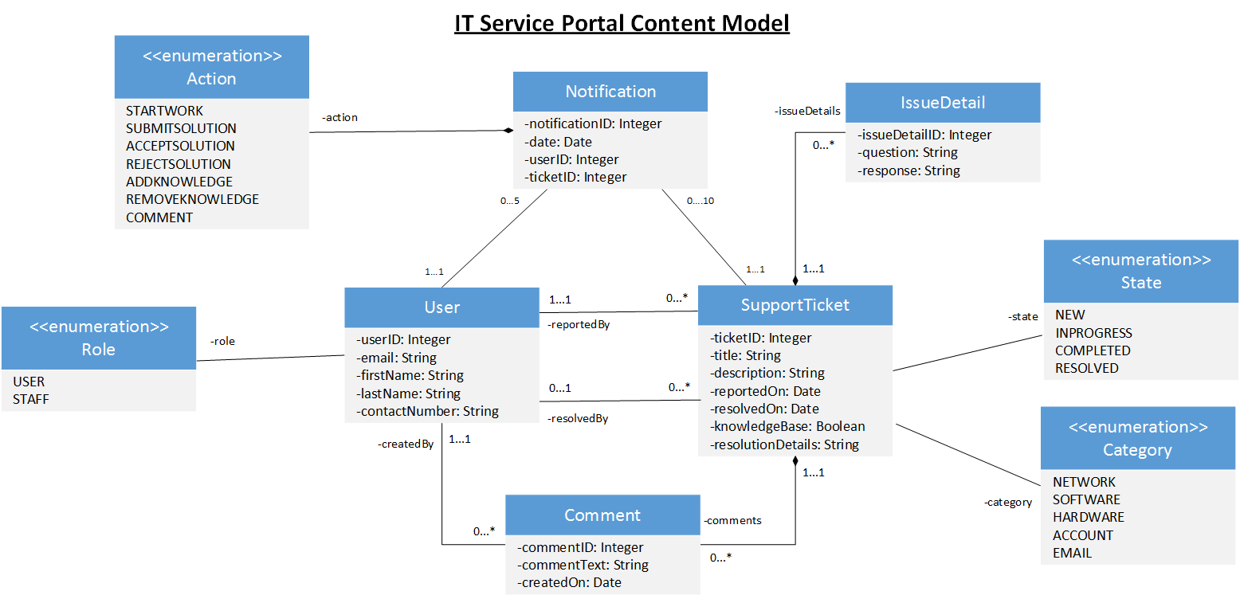

**NAVIGATION MODEL**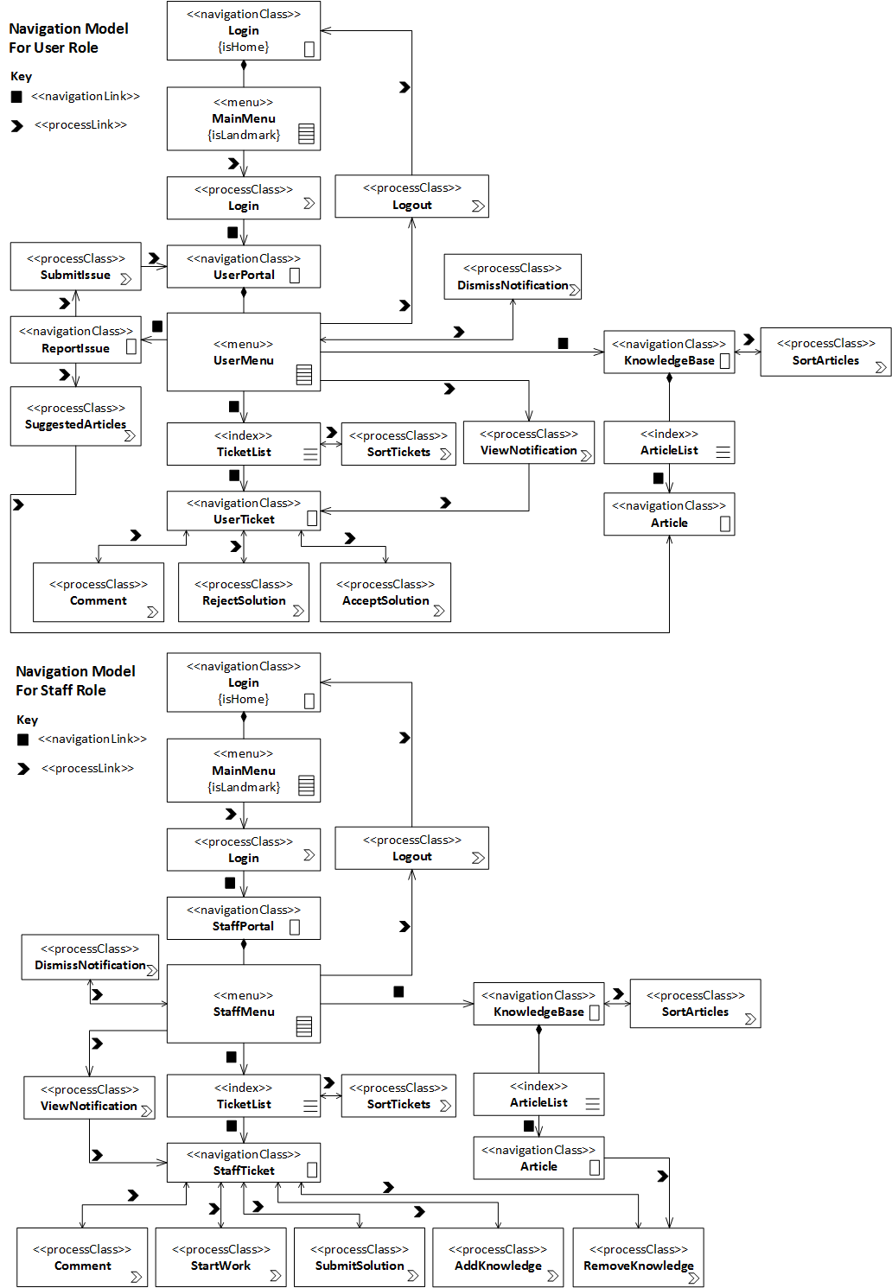

**PRESENTATION MODEL**

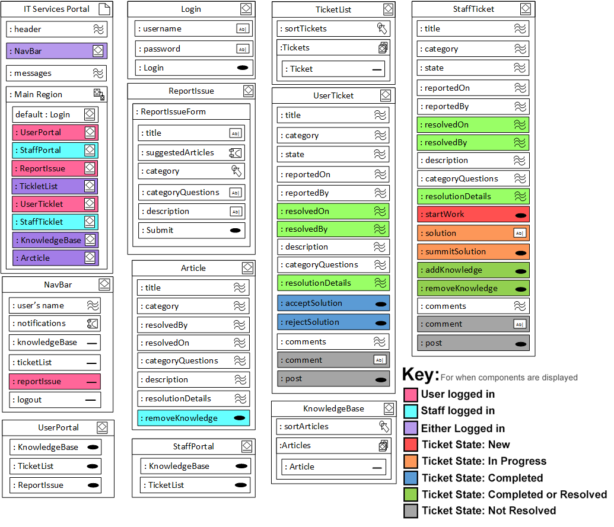

**DEVELOPMENT PLAN**

**Task Allocation**

We have discussed our group strengths and assigned tasks accordingly.

* Brice Purton will primarily work on the View
* Jonathan Williams will primarily work on the Database and Data Access Model
* Wajdi Younes will primarily work on the Controller and Model

However, tasks may require multiple input and assistance from other members. As this is a group assignment we’ll be sharing a lot of the workload and tasks to make sure our web application integrates seamlessly.

**Integration Plan**

We will be using Git version control with a private GitHub repository from easy collaboration on our project. Development will be done in an MVC design pattern allowing each member to work separately on different concerns without preventing progress in other areas. Tasks will be broken down into logical groupings and worked on sequentially by each group member where the concern matches their primary task allocation. Once each task group is completed it will be integrated into the application then work on the next task group will commence.

**Time Line**

